AWS EC-2 Task

1. Launch one EC2 using Amazon Linux 2 image and add a script in user data to install Apache
I have launched an amazon linux instance and added a script in user data
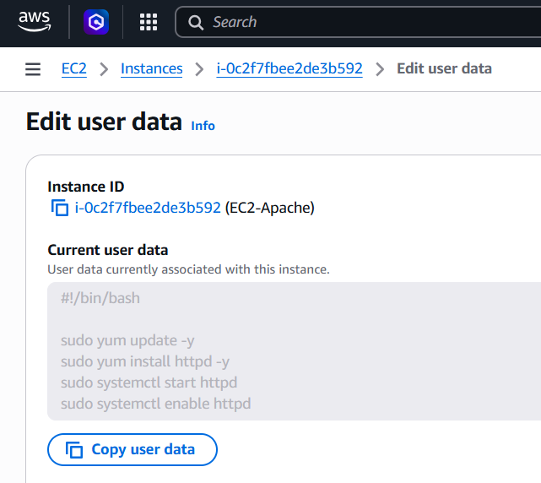

Then you can see, I connected it to that instance using ssh
And checked the apache is started or not, you can see that it is running now
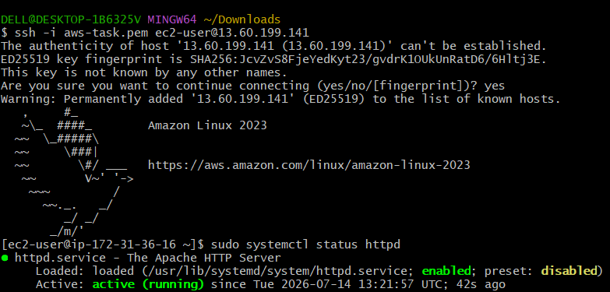

2. Launch one EC2 using Ubuntu image and add a script in user data to install Nginx.
I have launched an ubuntu instance and added a script in user data

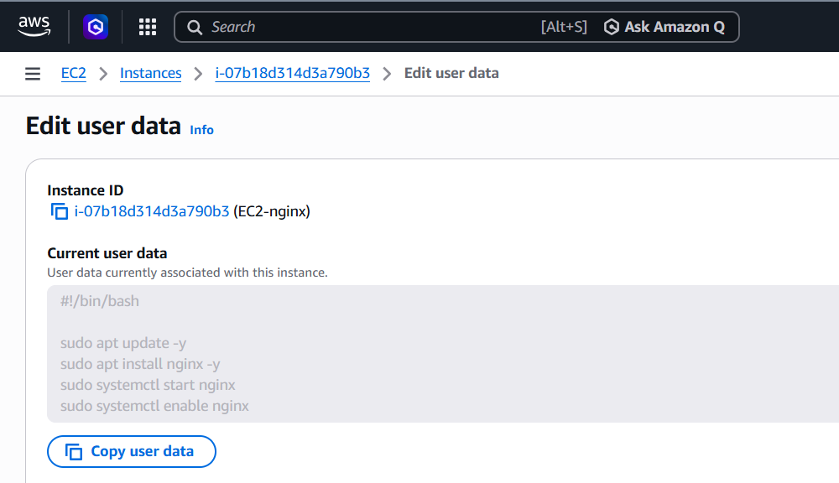

Then you can see, I connected it to that instance using ssh
And checked the apache is started or not, you can see that it is running now

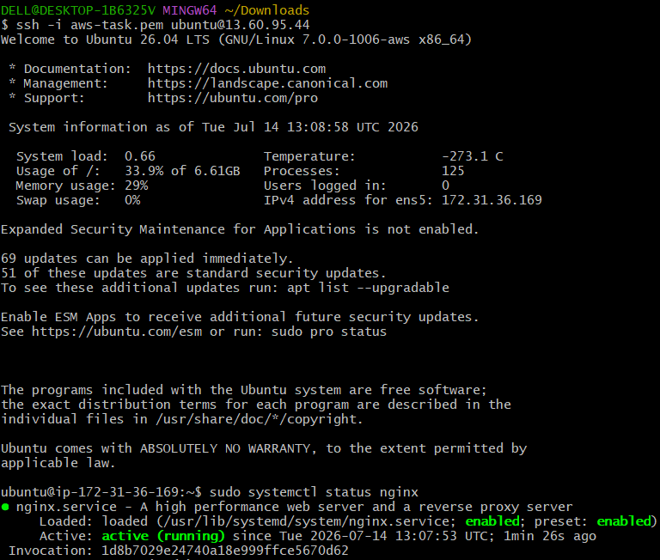

3. Launch one Windows server and install Tomcat on Windows.
First we need to create an instance,
Then connect and you can see the RDP over there, download the RDP shortcut file and connect
Before that you need to click on get password and upload the PEM key file and get the decrypted password and connect using it
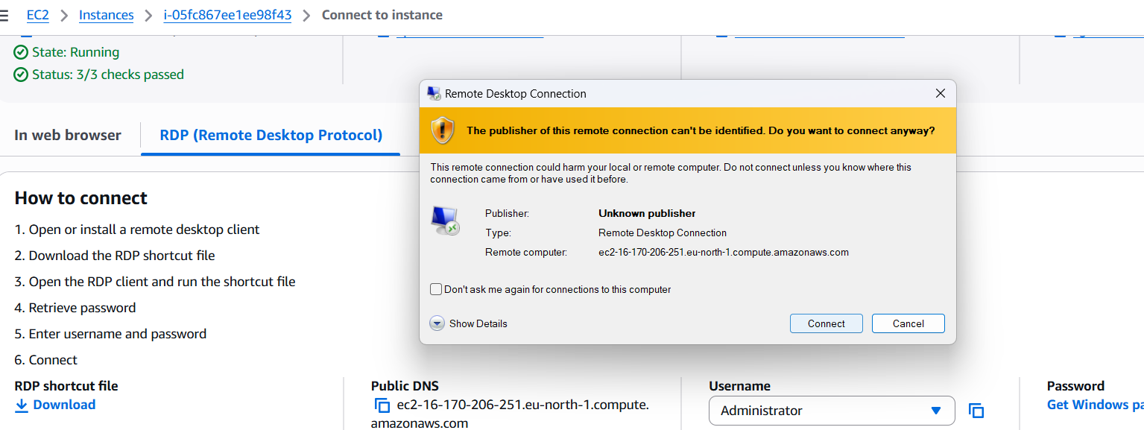
So you can see the RDP desktop has been opened


In that you can manually download java and tomcat and run with hppt://localhost8080
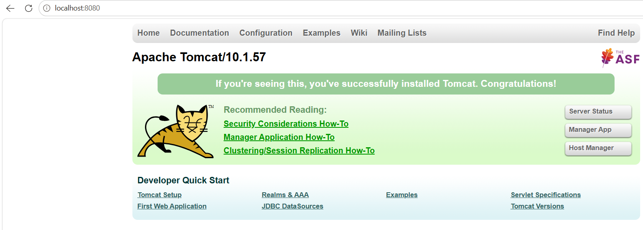

4. Take a snapshot of the instance created in Task 1
Snapshot is just saving point or undo the action, so that you don’t want to create a new instance if you have any conflicts during your work or servers
Go to the server and actions, there you have the option to create a snapshot

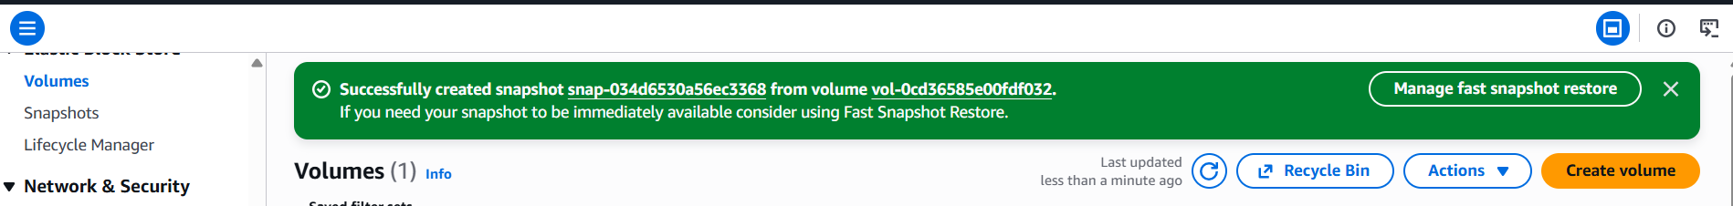
Create a snapshot and you can make use of it
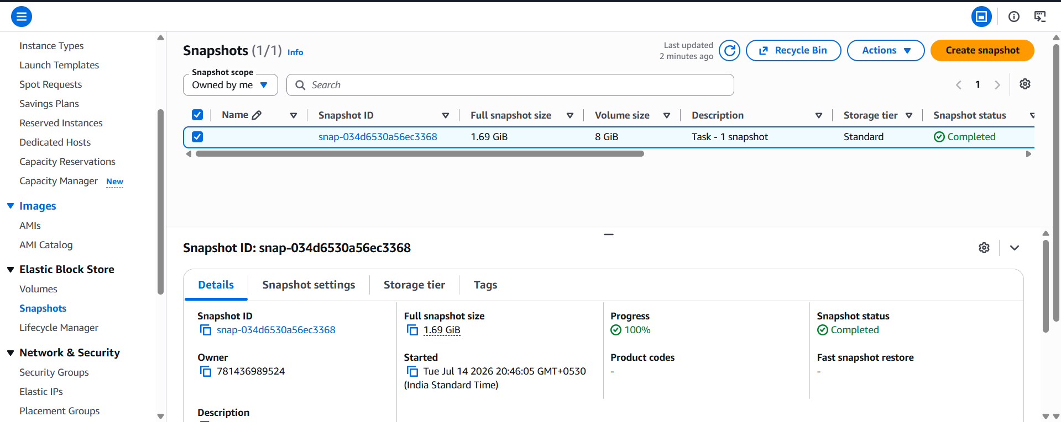

5. Assign password less authentication for the EC2 created in Task 2
In task 2 we have created a ec2 instance with ubuntu added nginx user data to it.
We already have the ssh keygen in our local
We can check it in ~/.ssh/.pub
Log in into the instance and,
Copy the key file with vi ~/.authorized_keys and copy the key and save it.
And again try connecting through ssh ec2-user@public IP, it connects
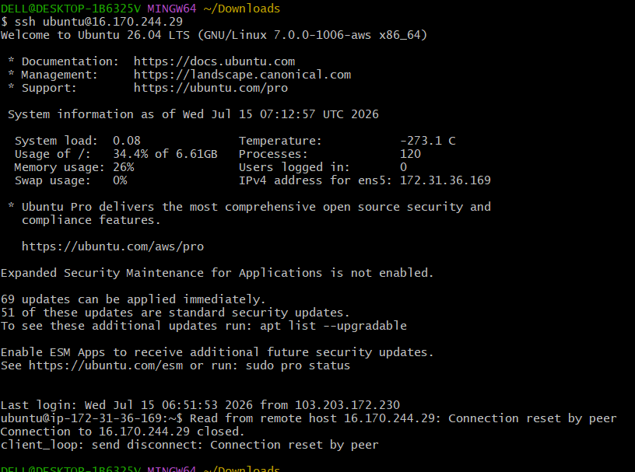

6. Launch any EC2 using the spot purchasing option
Create an instance, while creating I advance details click on spot instance
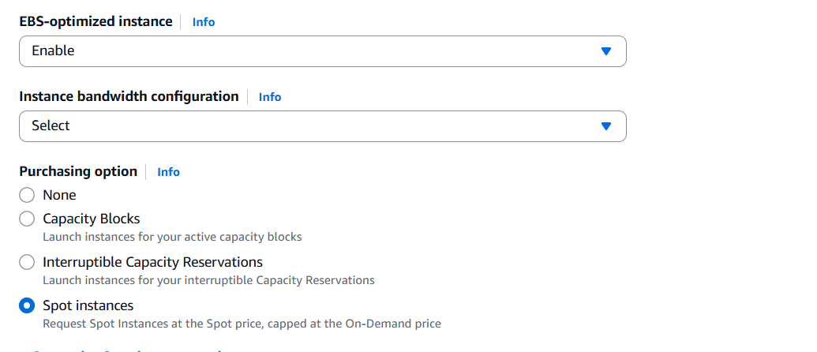
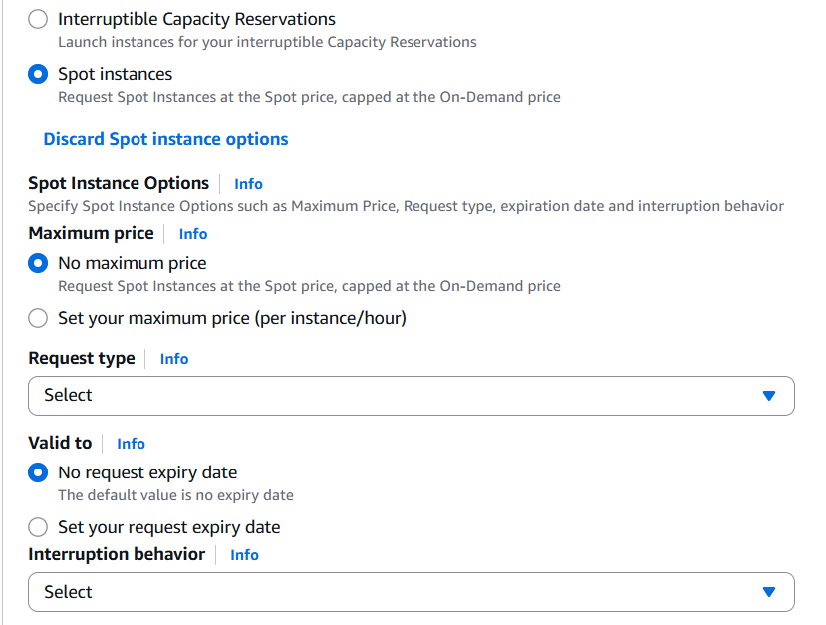
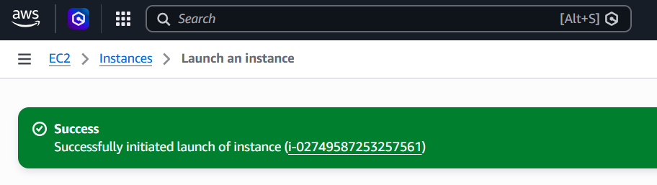
7. Enable termination policy on the EC2 created in Task 2.
In task 1 we created a ec2 instance with apache in user data.
Select that instance and go to instance settings-termination protection-enable
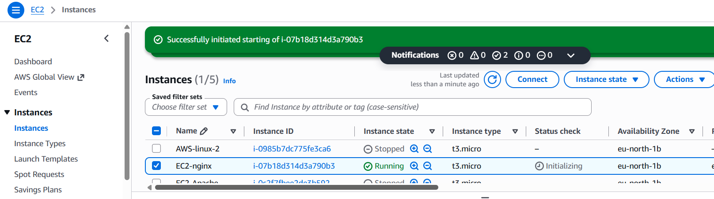
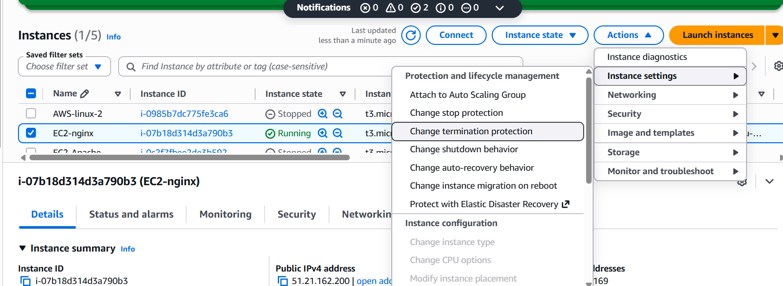
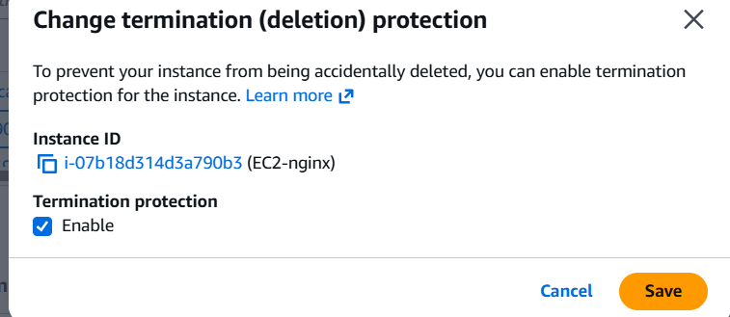
8. Launch one EC2 using AWS CLI
Launch instance name with aws
And connect to the server then Wget download cli
https://awscli.amazonaws.com/AWSCLIV2.msi
Now go to the instance and user profile, you can see the security credentials
In that create access key and copy it
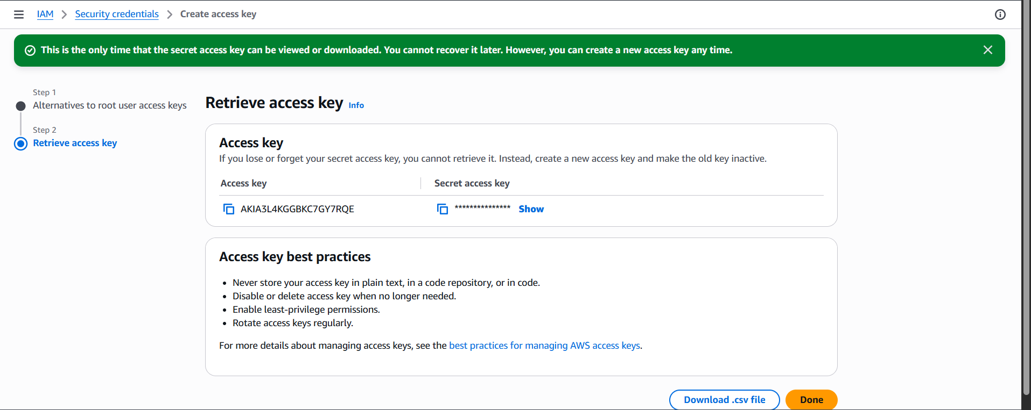

Then go to the git bash and click on aws configuration and configure using the access key
Once it is done, give aws ec2 describe-instance, there you can see as the below screen shot

